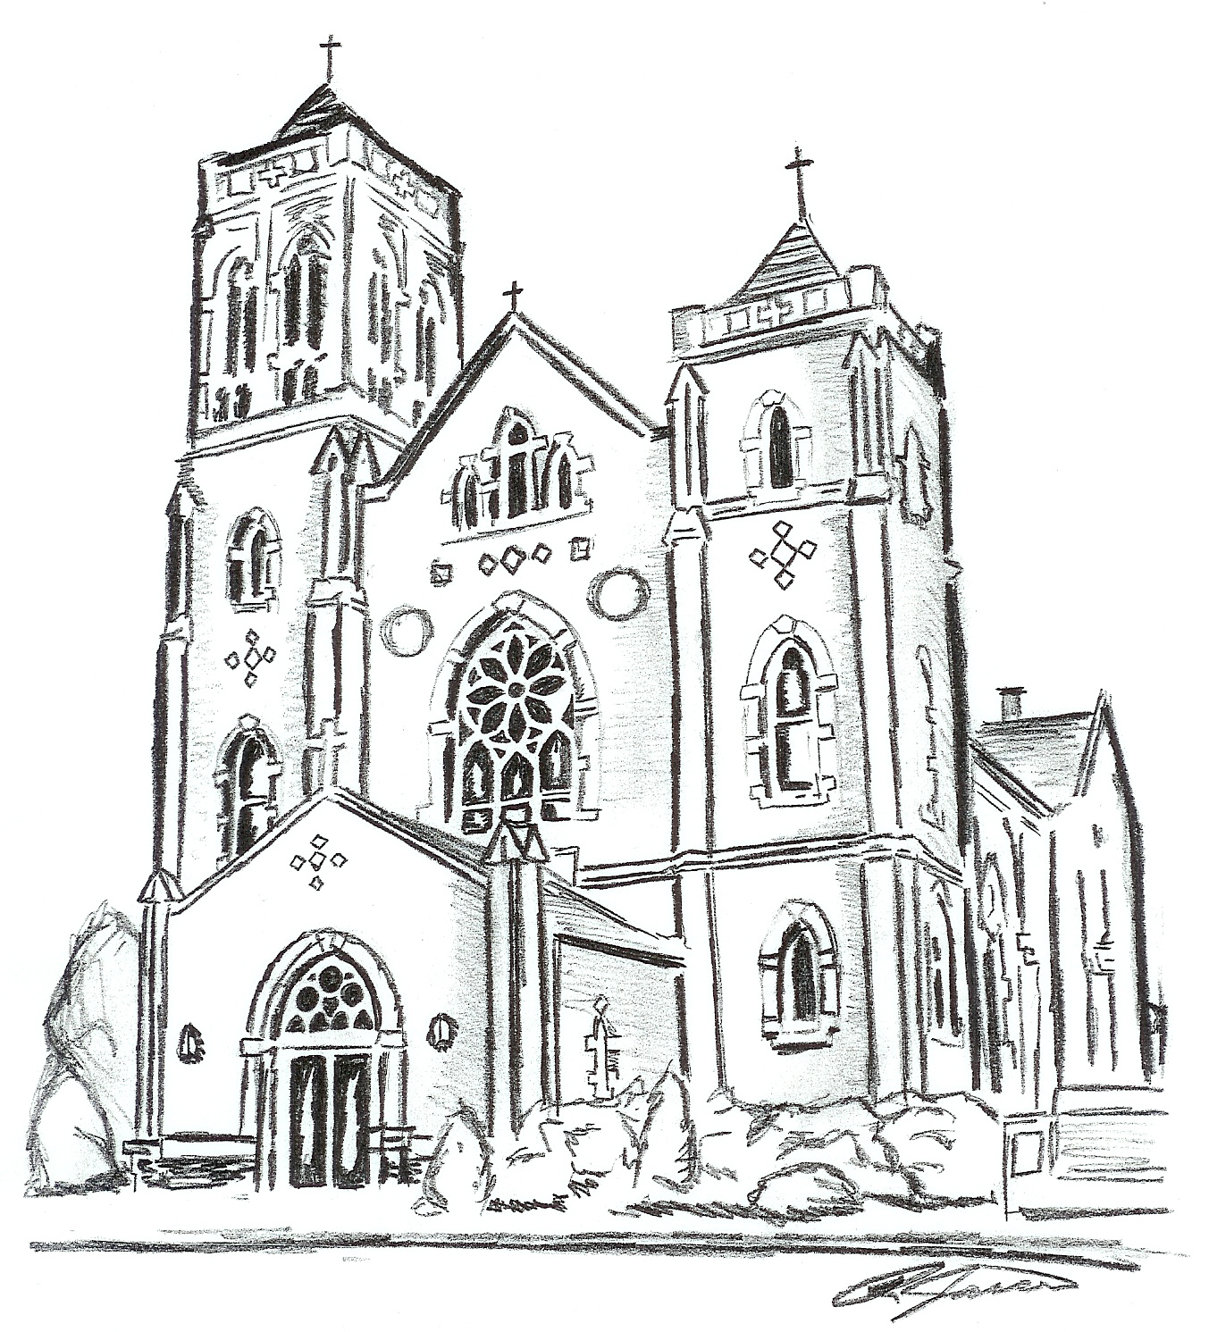
St. Bernard Parish

Founded 1908
202 N. Broadway — Box 10
Albers, Illinois 62215
Phone: (618) 248-5112
Fax: (618) 248-5595

PARISH COUNCIL CONSTITUTION
June 7, 2017

MISSION STATEMENT

Our mission as St. Bernard Parish, under the guidance of God’s Spirit in his Church, is to be a community of people, of all ages, who strives to live as Jesus Christ did by worshiping together, working together, caring and sharing within, and beyond, our parish family.

ARTICLE I. Name

The name of this organization shall be St. Bernard Parish Pastoral Council.

ARTICLE II. Purpose and responsibility

Section 1. The Council shall advise and assist the Pastor.

Section 2. The Council shall be the body wherein the clergy and laity of the parish come together regularly to take council as to the life of the Church.

Section 3. The Council shall be in a leadership role to advise and assist the Pastor with matters pertaining to the activities of the parish, both spiritual and temporal. St. Bernard shall maintain a close relationship with St. Damian Parish and foster unity to the best of its ability.

Section 4. The Council’s work shall encompass:

Paragraph 1. The spiritual growth of all parish members.

Paragraph 2. The coordination of parish ministries and activities.

Paragraph 3. The initiation of added activities to fulfill the aims and objectives of parish life, especially as expressed by Vatican Council II.

Paragraph 4. The physical properties of the parish, existing and future.

Section 5. The Pastor shall seek the advice and recommendations of the Council in matters pertaining to, connected with or resulting from the affairs of the parish.

Section 6. The Pastor shall give due consideration to the advice and recommendations of the Council and shall not disregard same without reasonable and justifiable cause.

Section 7. The role of the Council shall be:

Paragraph 1. One of Catholic leadership primarily within the family of St. Bernard, however, the Council can exist only within the wider Church of the Diocese of Belleville, the State of Illinois and the Universal Church.

Paragraph 2. The Council shall be primarily responsible to the Pastor and the parishioners.

Paragraph 3. The authority of the Council shall be one of leadership and service, not of power.

Section 8. The responsibility of the Pastor shall be:

Paragraph 1. As Leader of the parish, he shall be responsible for all decisions made at the council meetings. He shall foster a productive relationship with the council so that he may be enabled to make the best choices in matters affecting the parish.

Paragraph 2. The Pastor, in justice, may not supersede, ignore or void the actions of the Council, without due and just cause.

Section 9. The relationship between the Pastor and the Council must be one of respect and of mutual accord within the Gospel command of leadership and love.

ARTICLE III. Representation of the Council

Section 1. The numerical membership of the Council shall consist of ten (10) voting members and two (2) non-voting members. All effort shall be made to maintain equality between men and women. The voting members shall include nine (9) men and women, elected at large, and the Pastor. The two (2) parish trustees shall serve as non-voting members of the Council. Anyone in a leadership role of the parish, including but not limited to, representatives of the Men’s Sodality, Ladies’ Sodality and Catholic Youth Ministry, is always welcome to attend as a non-voting member.

Section 2. At the October meeting, the President of the Council shall appoint an Election Committee consisting of those Council members whose terms are expiring. Their responsibility shall be: (1) To announce to the parish of the upcoming election. (2) To solicit from the parish at large any person willing to have his/her name placed on the ballot and/or to nominate other parish members to be considered to fill vacancies. (3) To compile a list of nominees and volunteers and to present this list to the Council at the December meeting where the Council, through a discernment process, will select the names of one (1) to four (4) male and one (1) to four (4) female parish members, as appropriate, to be placed on the ballot or appointed (see Section 3 below). (4) The nominees will be approached by the Election Committee to assure that they will accept membership on the Council if elected.

Section 3. Only members of the parish, in spiritually good standing as judged by the Pastor, eighteen (18) years of age or older shall be eligible for nomination to the Council. No two (2) members of the same household may serve on the Council at the same time.

Section 4. If the Council cannot get enough nominees to hold an election, the Council, with the Pastor’s blessing, may appoint one (1) to three (3) willing members to serve on the Council without a ballot.

Section 5. Election to membership on the Council shall be held in December or January.

Section 6. The Election Committee shall be responsible for conducting the election by means as designated by the Council.

Section 7. The Election Committee shall tabulate the ballots of said election and submit the results, along with the ballots, to the Pastor. All candidates shall be notified of election results prior to publication of same. The Pastor shall publish in the weekly parish bulletin the names of the newly elected members of the Council.

Section 8. Any member of the parish eighteen (18) years of age or older, as of the date of the election, shall be entitled to one (1) ballot in the annual election. Absentee ballots may be requested from the parish office and submitted prior to the election.

Section 9. Procedures for tenure and office rotation for Council members are as follows:

Paragraph 1. The tenure of office for elected Council members will be determined by rotation of the elected members each year with each member serving a three (3) year term with an option for a second three (3) year term.

Paragraph 2. An elected member of the Council shall not serve more than two (2) consecutive terms.

Paragraph 3. The term of office for all Council members shall begin in January.

Section 10. In the event a vacancy occurs, the Council shall appoint someone to fill the vacancy from the list of selected nominees per the December meeting.

Section 11. Any council member can be removed for sufficient cause, including failure to attend three (3) consecutive meetings, extended physical or mental incapacity, or a change in eligibility status. The member whose removal is proposed will be given the opportunity for a hearing at a closed session of the Council. The Council will determine the action to be taken. A Council member may resign by filing a written resignation with the Council secretary or president.

ARTICLE IV. Meetings

Section 1. The Council will meet on the “even number” months of the year rather than every month, unless a special meeting is necessary.

There will be a two (2) hour time limit on meetings. Notice of such meetings of the Council shall be published in the weekly parish bulletin on the prior Sunday.

The Council may communicate via electronic media. For example, the Secretary may send the minutes to the Council members via email, allow time for feedback and accept approval (absence of email reply) in order to distribute in a timely manner. Electronic media may be used for other Council communication in between meetings. A provision will be made for any Council members without electronic media.

Section 2. Regular meetings of the Council shall be open to all members of the parish.

Section 3. The right of parish members to address the Council shall be limited to those whose petitions, verbal or written, have been approved in advance of the meeting by the Council President.

Section 4. A quorum shall consist of a 1/2 (5 of 10) majority of the Council members.

Section 5. In compliance with the Code of Canon Law (1983), the Council shall be a consultative body to the Pastor. Ordinarily, this consultation shall be exercised within a consensus decision-making environment, which includes dialogue, compromise and modification. If all members cannot reach an agreement to bring about the peace of the Lord, the Pastor shall make the decision for the good of the parish.

Section 6. Special meetings of the Council may be called by the President or Pastor. Members of the Council shall be notified as to starting time, place, and purpose of the meeting. Special meetings may also be called at the written request by at least three (3) members of the Council to the President or Pastor.

Section 7. The President of the Council has the privilege of calling a closed meeting of the Council members.

Section 8. The agenda at any meeting shall be as follows:

Paragraph 1. Regular meetings:

- Call to order

- Prayer/formation

- Approval of minutes of last meeting, unless the minutes have been previously approved via email

- Committee reports

- Old business

- New business

- Adjournment

Paragraph 2. Special meetings:

- Call to order

- Prayer

- Reading of official call for meeting

- Transaction of the business for which the meeting is called

- Adjournment

ARTICLE V. Officers

Section 1. The members of the Council shall elect, if all are in agreement, by acclamation from among the lay members of the Council, a President, a Vice President and a Secretary of the Council. It may use a ballot if necessary. This should take place at the February meeting.

Section 2. The President shall preside at all regular meetings. The President, after consulting with the Pastor, shall call special meetings when needed. With input from the Council, the Church secretary shall prepare the agenda for all meetings.

The Vice-President shall perform all the duties of the President when the President is absent or unable to act.

The Secretary shall maintain a written record of all meetings and send out correspondence as necessary. The Secretary shall make the minutes available to parishioners using whatever means possible (bulletin, website, etc.).

Section 3. Every parish in the Diocese of Belleville is a separate and distinct corporation. The Bishop is ex-officio trustee to every parish of the Diocese. Each parish shall have four (4) other trustees who are appointed by the Bishop. The Vicar General and the Pastor will be trustees as long as they continue in their respective office in the Diocese. Two (2) members of the parish all hold office as trustees for one (1) year, or longer, not however, exceeding three (3) years, after which period the same trustees may be reappointed to a successive term. The two (2) lay trustees will be appointed by the Bishop after recommendation from the Pastor with the aid of the Council.

The trustees of the parish or corporation shall have no power or authority to sell or purchase property, borrow money, erect a building, make contracts or improvements upon the property or buildings of the parish, except in pursuance of a special resolution to that effect, signed by the majority of the trustees of the parish, which said majority shall always include the Bishop of the Diocese, or in his absence the Vicar General. Such resolution is mandatory whenever the expenditure of improvements amounts to or exceeds $5,000.00

ARTICLE VI. Committees

Section 1. The Council shall create committees that reflect the needs of the parish, with the exception of the Finance Committee, which shall remain a standing committee. The President shall appoint Council members as needed. One (1) Council member or trustee shall serve on the Finance Committee.

Paragraph 1. Each committee, as applicable, shall report to all Council meetings.

Paragraph 2. Additional ad hoc committees may be formed as necessary.

Paragraph 3. No committee shall have precedence over the other in authority.

Paragraph 4. Each committee may cooperate or collaborate with any other committee and/or submit joint reports to the Council.

Section 2. The standing committee shall be Finance. Other committees may include:

- Liturgy
- Education
- Building/Maintenance/Cemetery
- Service

Section 3. Duties and responsibilities of the committees shall be:

Paragraph 1. The Finance Committee shall be responsible for assisting the Pastor in developing an annual budget, an annual account of parish expenditures, the investment of parish funds and developing ways and means of raising funds, both parish and diocesan.

ARTICLE VII. Amendments

Section 1. Amendments to the Council Constitution may be made by the following procedures:

Paragraph 1. Study by and ad hoc council committee appointed by the President.

Paragraph 2. Proposals by Council members at any council meeting.

Section 2. The proposal for an amendment to the Constitution will not be acted upon at the time of initial discussion but must be tabled and considered at the subsequent meeting. Approval of any proposed amendment will be decided upon by the Council members present at the meeting.

ARTICLE VIII. Conflict Resolution

Section 1. In the event of an irreconcilable conflict between the Pastor and the Council, arbitration shall be sought by both the Pastor and the Council. This must follow the Due Process and Arbitration procedures within the Diocese of Belleville and the Office of Bishop.

Section 2. The Council may be dissolved only by the direct action of the Bishop, mutual agreement of both Pastor and Council members, or the decision of the arbitration process of the Diocese of Belleville.

